VALUVISTA: ML Powered Customer Lifetime Value Prediction for Intelligent Insights
Sujith Shreyas R^{1, a)}, Vasanth B^{1, b)},
Harivishnu M^{1, c)}, Jayanthi P^{1, d)}
¹Department of Computer Science and Engineering (Emerging Technologies), SRM Institute of Science and Technology, Vadapalani Campus, Chennai, India.
^{a)}gedionsujith@gmail.com ,^{b)}vasanthbas07@gmail.com ,^{c)}vishnuharish46@gmail.com ,^{d)}mailtojayanthi.p@gmail.com

Abstract. This paper discusses the significance of Customer Lifetime Value (CLV) as an important e-commerce metric, predicting revenue per customer throughout their lifetime. It describes different machine learning methods for estimating CLV, from Linear Regression to more complex models such as Decision Trees and Neural Networks. Models are evaluated based on Root Mean Squared Error (RMSE) and R-squared for segment-wise accuracy. The project evaluates multiple machine learning models for Customer Lifetime Value (CLV) prediction, balancing accuracy and complexity. Linear Regression achieved 86.5% (R² = 0.8656) but struggled with non-linearity, while the Decision Tree Regressor improved to 86.9% (R² = 0.8695) but risked overfitting. Random Forest achieved 84.1% (R² = 0.8416), and Gradient Boosting reached 82.7% (R² = 0.8269). The best-performing model, the Neural Network (MLP Regressor), achieved 87.3% (R² = 0.8739). These insights help optimize customer retention and marketing strategies.

Keywords: Customer Lifetime Value (CLV), E-commerce, Data-driven Decision Making, interquartile range (IQR).
- INTRODUCTION
In today's competitive e-commerce landscape, understanding customer behavior is crucial for long-term success. Customer Lifetime Value (CLV) is a key metric that measures the total revenue a customer will generate over their relationship with a company [1]. It helps businesses optimize marketing efforts, personalize customer experiences, and allocate resources efficiently. Traditional CLV methods rely on basic heuristics or past spending, which may not predict future behavior accurately. With the advent of machine learning, more advanced, data-driven methods are now possible, enabling companies to make precise forecasts [2].

The proposed ‘ValuVista’ system compares machine learning algorithms for forecasting CLV, starting with Linear Regression and advancing to Decision Trees, Random Forests, Gradient Boosting, and Neural Networks. These models are trained on past customer data, such as purchase frequency and transaction value, to predict future CLV. We identify the best business methods by evaluating model accuracy, interpretability, and scalability. The study also explores factors influencing CLV, like seasonal trends, retention rates, and product categories, while assessing model performance through metrics like RMSE and R-squared. Additionally, the system highlights the importance of feature engineering, such as selecting the right attributes and handling noisy data, to improve model accuracy. The practical implications of CLV forecasting include targeted marketing, loyalty programs, and optimized inventory management, all of which enhance customer satisfaction and profitability. With vast transactional data now available, machine learning enables better decision-making and resource allocation. However, challenges remain in model interpretability and real-time learning integration, which are key for responsive, dynamic forecasting. This study lays the foundation for scalable CLV prediction models that adapt to changing market trends. As e-commerce grows, integrating predictive analytics will be vital for sustaining a competitive edge, helping businesses maximize customer value, and improving long-term performance.

- RELATED STUDY

Classic CLV models use statistical techniques like RFM for customer segmentation, but they fail to adapt to changing behaviors. Regression models (linear/logistic) are common but constrained by linearity assumptions, limiting advanced data usage [3]. Bayesian models (BG/NBD, Pareto/NBD) improve CLV estimation by predicting transaction probabilities, but they still rely on rigid assumptions. Churn prediction traditionally used survival analysis (e.g., Cox model), which, despite being designed for time-to-event data, does not meet modern business needs. A more dynamic, data-driven approach is required [4]. Machine learning enhances CLV prediction by handling complex relationships. Decision Trees, Random Forest, and Gradient Boosting identify nonlinear patterns in customer behavior. Neural networks (MLPs) further improve CLV estimation but demand high computational resources [5]. Clustering methods (k-means, hierarchical) help in customer segmentation but require careful tuning. Reinforcement learning is an emerging approach that adjusts marketing strategies dynamically to optimize long-term customer engagement. ML models improve churn prediction by integrating behavioral, transactional, and engagement data [6]. Decision Trees, Random Forest, and XGBoost handle high-dimensional data, while deep learning models (RNNs, LSTMs) capture sequential dependencies in customer interactions. Feature engineering, including clickstream analysis and sentiment data, boosts accuracy [7]. Hybrid models combining deep learning with ensemble methods improve performance and interpretability, making churn prediction more robust. With increasing ML adoption, explainability is critical. Techniques like SHAP and LIME help interpret model decisions, ensuring alignment with business goals and ethics. A counterfactual analysis enhances understanding by showing how small changes impact predictions. Regulatory policies (e.g., GDPR) emphasize transparency, pushing businesses toward explainable AI. Advancements like interpretable models (decision sets, GAMs) and multimodal explainability help businesses extract insights while maintaining control over decision-making [8].

- METHODOLOGY
The ValuVista system starts with data collection and preprocessing, then progresses through exploratory data analysis (EDA), feature engineering, model training, testing, and result interpretation (Fig. 1). The dataset, provided by a UK-based online shopping company, includes transaction details such as invoice IDs, customer IDs, purchase quantities, unit prices, and timestamps. From this, the system progresses to model training, evaluation, and selection of the best-performing model based on predictive accuracy.
  - Data Collection and Preprocessing
3.1.1 Data Collection
The Online Retail II dataset, sourced from the UCI Machine Learning Repository, contains transactional data from a UK-based online retail company operating between December 2009 and September 2011 [9]. The dataset includes key features such as invoice number, stock code, product name, quantity, invoice date, unit price, customer number, and country. These attributes provide valuable insights into customer purchasing behavior, enabling the analysis of consumption trends and the prediction of future buying patterns. Given its structured format, this dataset is instrumental in designing machine learning models for predicting CLV and identifying potential customer churn.

3.1.2 Preprocessing:
Handling Missing Values. To ensure reliable input data for predictive modelling, preprocessing addressed missing values, particularly in crucial columns like customer IDs and product descriptions. Rows with excessive missing values were removed, while minor gaps were filled using mean or median imputation. This step enhances data reliability, preventing prediction failures in machine learning models.
Outlier Detection. Outlier detection was conducted using IQR to identify suspicious transactions, such as extremely high or low purchase values. The dataset included negative values and anomalies, which could negatively impact model performance. The Interquartile Range (IQR) method was used, leveraging Q1 and Q3 to establish acceptable value ranges. Outliers were either adjusted or removed to prevent their impact on the learning process, ensuring models remain unaffected by extreme values that do not reflect normal customer behavior.

IQR = Q3 - Q1 (1)
Lower Bound=Q1−1.5×IQR (2)
Upper Bound=Q3+1.5×IQR (3)

3.2 Exploratory Data Analysis (EDA)
Exploratory Data Analysis (EDA) plays a vital role in comprehending the data before implementing machine learning algorithms. In the ValuVista system, EDA was performed on the dataset. To identify patterns, correct anomalies, and maintain data integrity to improve CLV and churn predictions. Valuable insights were provided through statistical analysis and visualizations using Matplotlib and Seaborn.

Most Frequent Products and Stock Analysis. To determine the purchasing habits of the customers, bar graphs were drawn to chart the top ten most frequently purchased product descriptions and stock codes. The depiction assists in the identification of best-selling items and in-demand products in stock. Companies can enhance inventory management and streamline the supply chain based on the analysis of this data. The dataset indicates that some products, including decorative lighting and home accessories, were purchased more frequently, thereby constituting vital revenue generators (Fig 2).

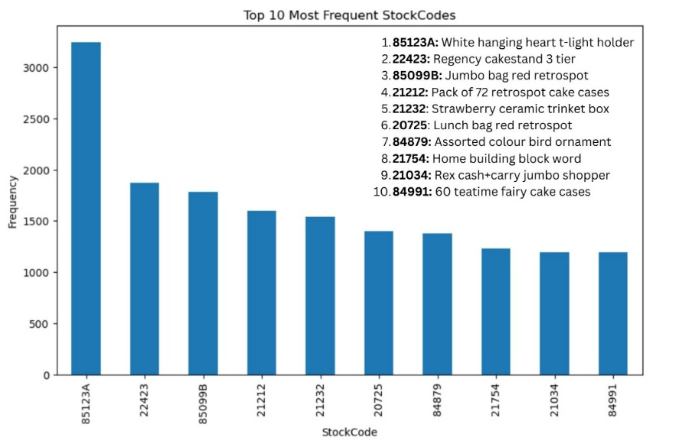
Fig. 2. Graphical Representation of Most Frequent Stock Codes.

Geographical Trends in Sales. EDA also included the analysis of country-wise sales distribution. A bar plot of country-wise transaction frequencies was drawn (Fig. 3), where the United Kingdom was at the forefront, followed by other European nations. The plot was drawn on a logarithmic scale to handle data skewness so that high- and low-volume areas could be easily compared. This information helps firms customize marketing campaigns for high-value areas and improve global supply chains.

Identifying Top-Selling Products and Customer Segments. Another important analysis that was conducted was the determination of best-selling items in terms of the total number sold. A bar graph was created, showing the best-selling items, which can be beneficial in promotional campaign building and inventory distribution (Fig 4).

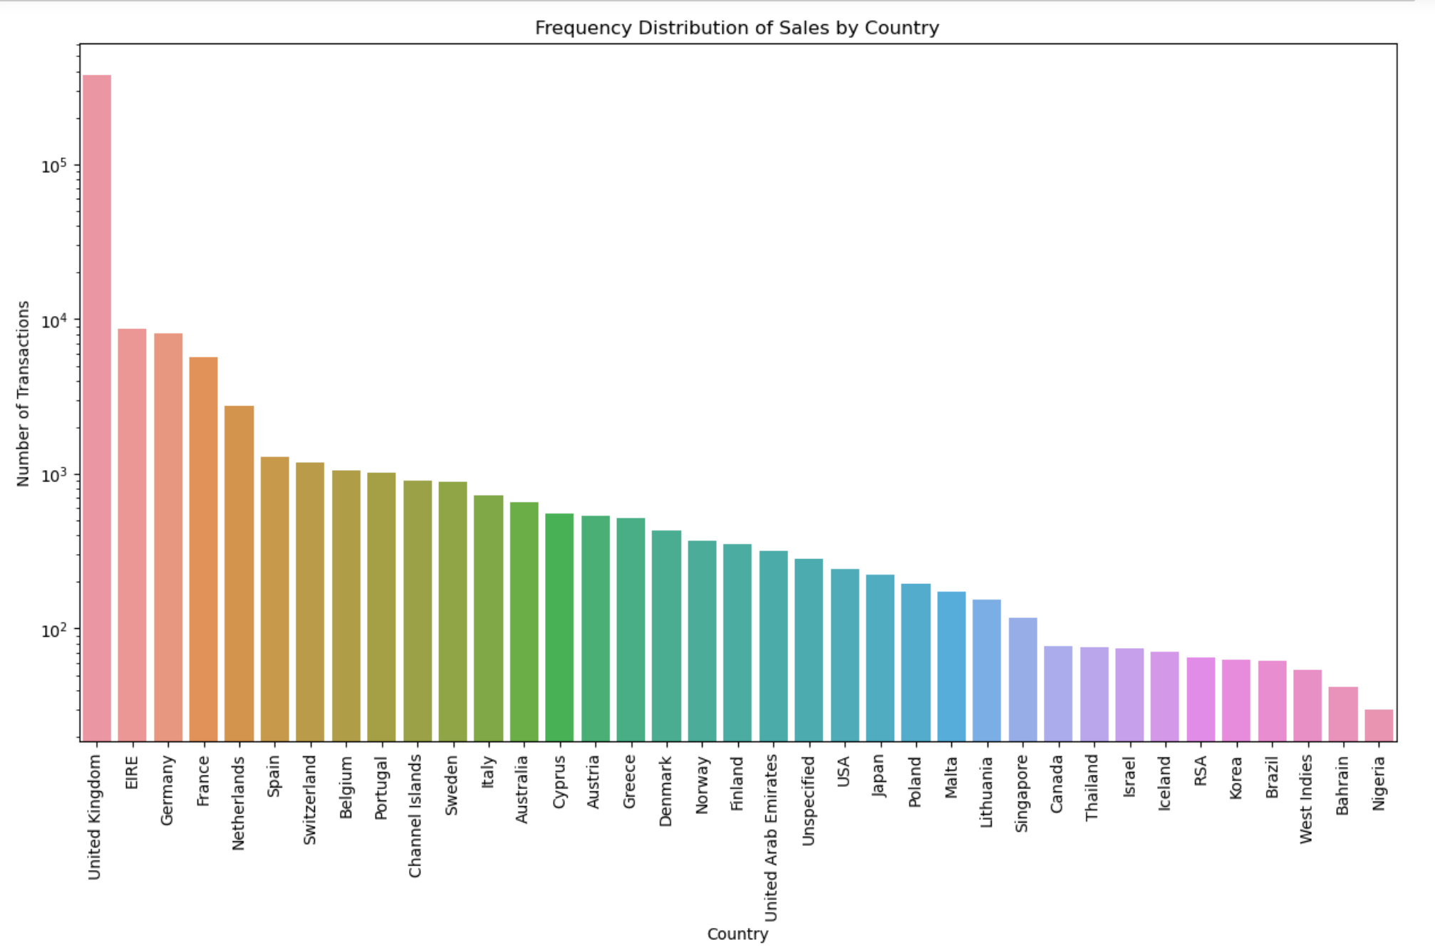
Fig. 3. Frequent Distribution of Sales by Country.
Additionally, the customers were segmented based on their total expenditure and categorized into segments such as low spenders, moderate spenders, and high-value customers. This segmentation allows for targeted marketing campaigns, customized discounts, and retention.

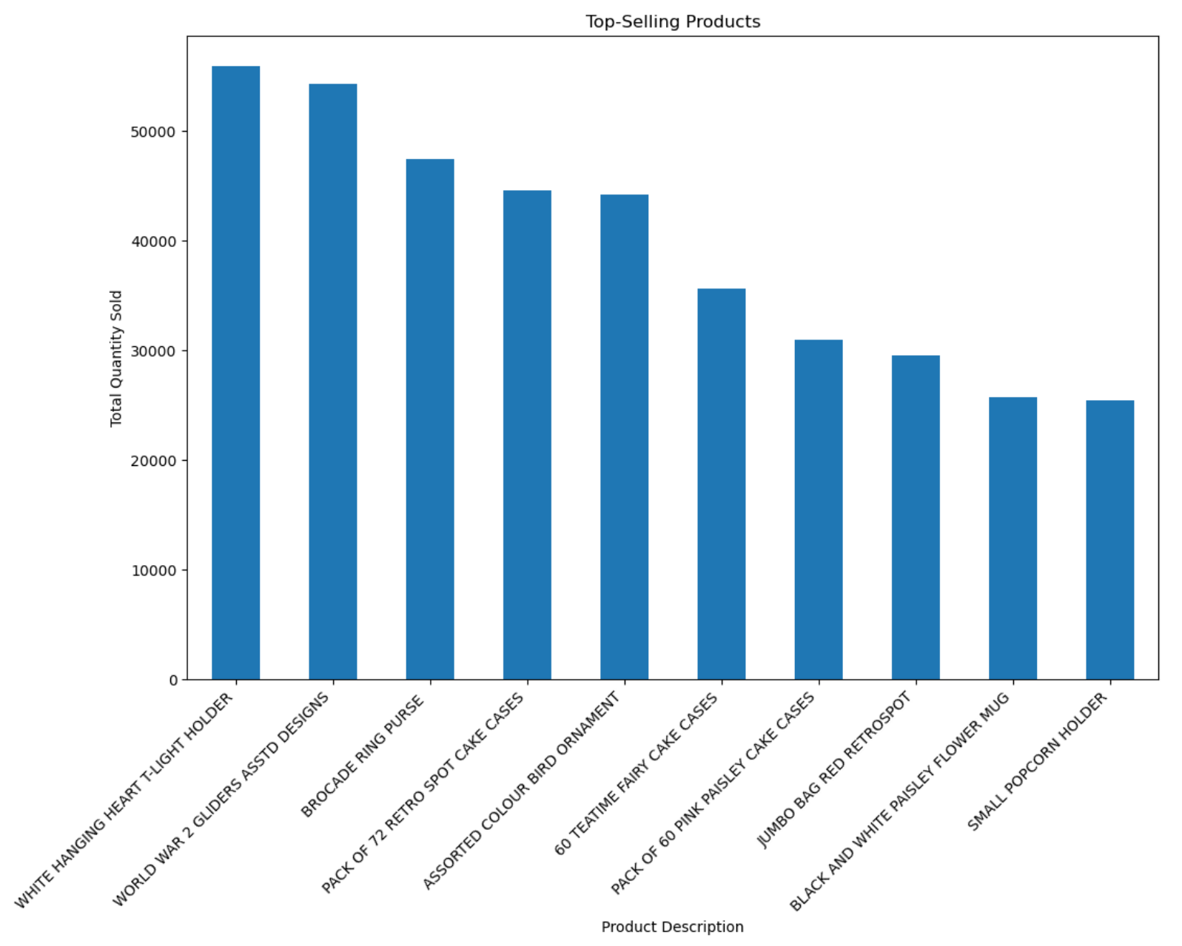
Fig. 4. Top Selling Products according to Quantity Sold.
Visualizing Customer Spending Behavior. To gain a deeper insight into the buying habits of the customers, a violin plot was designed to compare the quantity purchased across different countries (Fig. 5). The visualization helps in detecting order size differences and buying habits of buyers in different markets. This can be used to guide price levels and special promotion offers region-wise.
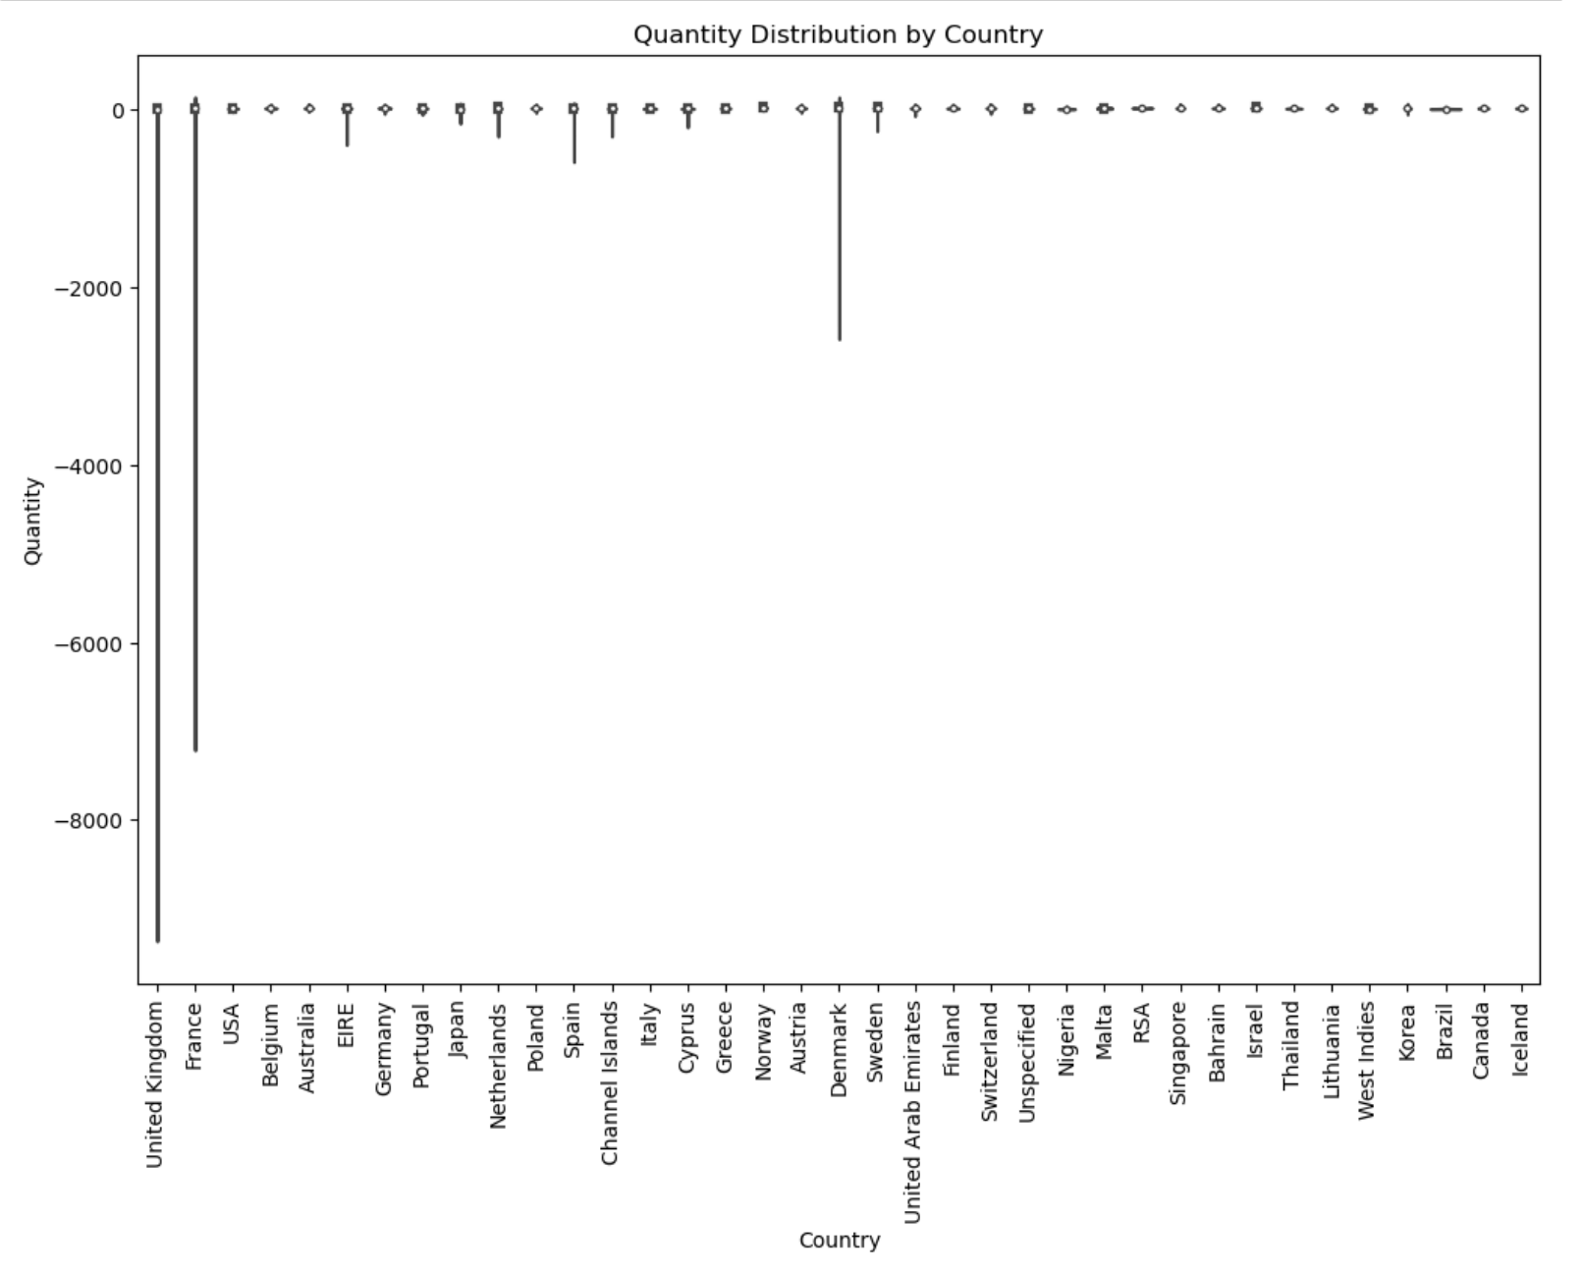
Fig. 5. Violin Plot for Quantity Distribution by Country.

3.3 Feature Engineering:
Feature engineering is an essential function in improving machine learning model performance by converting raw data into informative variables. In the proposed method, several important features were derived to improve the accuracy of CLV estimation and churn prediction. These are total sales calculations, time-based features, customer segmentation metrics, and churn labeling, which are all essential elements in providing better predictive performance.

Total Sales Calculation. One of the most critical attributes used in this research is Total Sales, which is determined as Quantity x Unit price per transaction (Eqn 4). Total Sales is the most critical data, offering insight into the spending behavior of a customer, and is one of the principal predictors in CLV estimation. The Invoice Date was also converted to a datetime type for analyzing customer purchases based on time. Resampling the transaction data into daily, weekly, or monthly intervals allowed for determining revenue patterns and thus improving the capability to monitor changes in customers' purchasing behavior over time (Fig. 6).
Total Sales = Quantity × Unit Price (4)
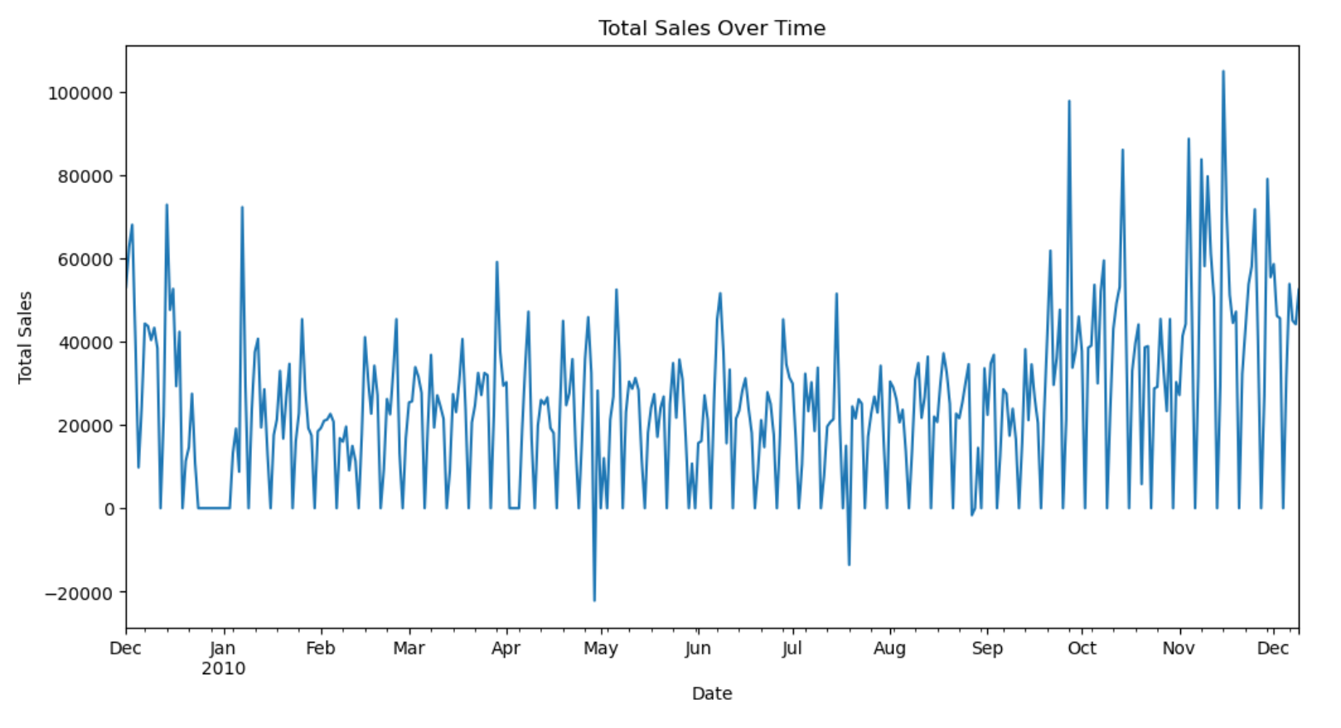
Fig. 6. Total Sales Calculation Over Time.
Customer Segmentation Using RFM Analysis. To enhance the predictive performance of the model, Recency-Frequency-Monetary (RFM) analysis was implemented.
- Recency (R): Represents the number of days since a customer's last purchase, reflecting engagement levels,
- Frequency (F): Captures how often a customer makes purchases, helping to identify repeat buyers,
- Monetary (M): Measures total spending, allowing businesses to recognize high-value customers [10].
These attributes were aggregated at the customer level and were essential for CLV prediction, enabling companies to differentiate between high-value and low-value customers.
Churn Labelling for Prediction. To facilitate churn prediction, customers were categorized as either churned or active based on their purchase history. A Decision Tree Classifier was used as the binary classification algorithm for churn prediction. A customer was considered churned (1) if no purchase had been made in the past 180 days, while those who had bought within this period were labelled active (0). This binary classification was crucial for training machine learning models, enabling proactive strategies for customer retention.

MODEL BUILDING
This study emphasized the selection and training of machine learning models for churn prediction and CLV prediction. Different models were experimented with and evaluated to determine the best for every task. Models such as Neural Networks, Decision Tree Regressor, Linear Regression, Gradient Boosting Regressor, and Random Forest Regressor were used in CLV prediction. They were trained on transactional data over time, wherein features such as total sales, purchase frequency, and recency dominated the formation of forecasts about customer expenditure in the future. Model performance was evaluated using R² score and RMSE. Neural Networks were effective in detecting complex patterns, and Decision Trees provided higher interpretability.
$RMSE = \sqrt{ \left(\frac{1}{n}\right)\sum{{\left(yi - ŷi\right)}^{2}}}$ (5)
$R^{2}= 1 - \left(\begin{aligned} Σ\frac{{\left(yi - ŷi\right)}^{2}}{} \\ Σ {\left(yi - ȳ\right)}^{2}\end{aligned}\right)$ (6)
Linear Regression. Linear regression is a basic algorithm used to predict CLV based on past data. Total Spend per customer is computed by multiplying the quantity with the price. The data is split into training (80%) and testing (20%) sets to train a regression model. The model predicts CLV using features like total quantity bought and average price per order. The model quality is measured using metrics like Root Mean Square Error (RMSE) and R-squared (R²) to measure the accuracy of the predictions.

Decision Tree Regressor. Decision Tree Regressor is utilized as a replacement for linear regression to handle non-linear relationships within CLV prediction [11]. The model separates the data into subsets according to feature importance and hence enables more flexible decision-making. Hyperparameter tuning is achieved through GridSearchCV to maximize parameters like maximum depth, minimum samples per split, and minimum samples per leaf. The optimized model is then tested based on Root Mean Square Error (RMSE) and R² metrics, and the outputs are contrasted with those of the linear regression model.
Random Forest Regressor. Random Forest is an ensemble learning algorithm that enhances prediction precision by averaging outcomes from many decision trees. It reduces overfitting by training across different subsets of data [12]. The model is trained with 100 trees, and its performance is measured in terms of Root Mean Square Error (RMSE) and R-squared (R²). The approach enhances generalization over one decision tree by aggregating many predictions, hence becoming more robust in dealing with complex data patterns.
Gradient Boosting Regressor. Gradient Boosting is yet another ensemble method that trains models sequentially and thus rectifies the mistakes made by the earlier models. It places greater importance on the wrongly predicted instances, thus improving precision with each set of iterations [13]. The model is trained using 100 estimators and a learning rate of 0.1, which yields competitive results when estimating CLV. Despite the probable computational cost, it typically provides better performance than single models.
Neural Network (Multilayer Perceptron - MLP). A Multilayer Perceptron (MLP) Regressor is used as a deep learning method to forecast CLV. It has a hidden layer of 100 neurons with ReLU as the activation function and Adam as the optimizer when training. The model is measured based on RMSE and R² metrics. The findings show that neural networks can efficiently identify intricate patterns in the behavior of customers and make more accurate predictions than conventional machine learning models. Hyperparameter tuning is required to avoid overfitting. Churn Prediction using Decision Tree Classifier. For churn prediction, a Decision Tree Classifier is used to predict the likelihood of a customer ceasing buying behavior based on historical purchase data. The churn label is given based on the last purchase date, where customers who have not purchased within the last 180 days are considered churned. The data are divided into training and test sets, and a classification model is then trained. The model performs with 100% accuracy on the test set, thereby proving its efficiency. Nonetheless, more testing on new data is needed to confirm its performance under real-world use.
- RESULT AND DISCUSSION
The performance of Customer Lifetime Value (CLV) forecasting models was tested and it was concluded that machine learning methods significantly improved revenue forecasting accuracy compared to traditional statistical methods (Fig. 7). Between CLV and churn prediction models, we saw ensemble learning algorithms like Random Forest and Gradient Boosting performing equally well in both tasks. While superior in CLV prediction, the interpretability of Neural Networks created practical issues for businesses in expectation of adaptation without the need for secondary explanation tools. Decision Trees, on the other hand, enabled highly accurate churn predictions while maintaining their interpretability and thus being more suitable to business applications that demand transparency.
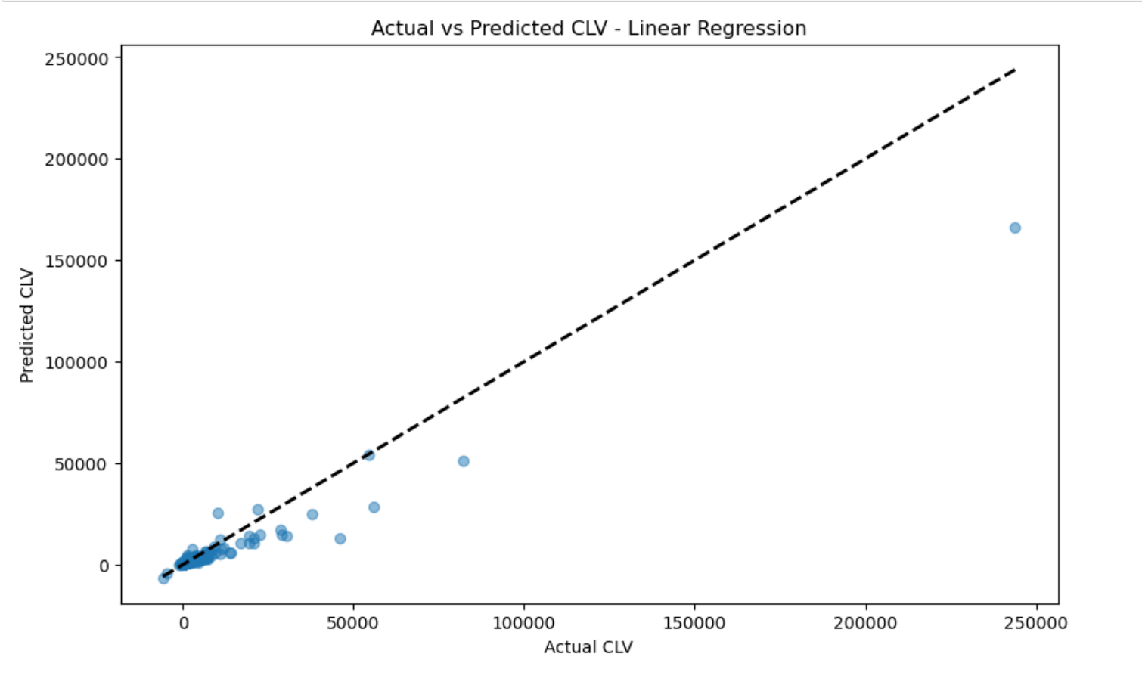 | 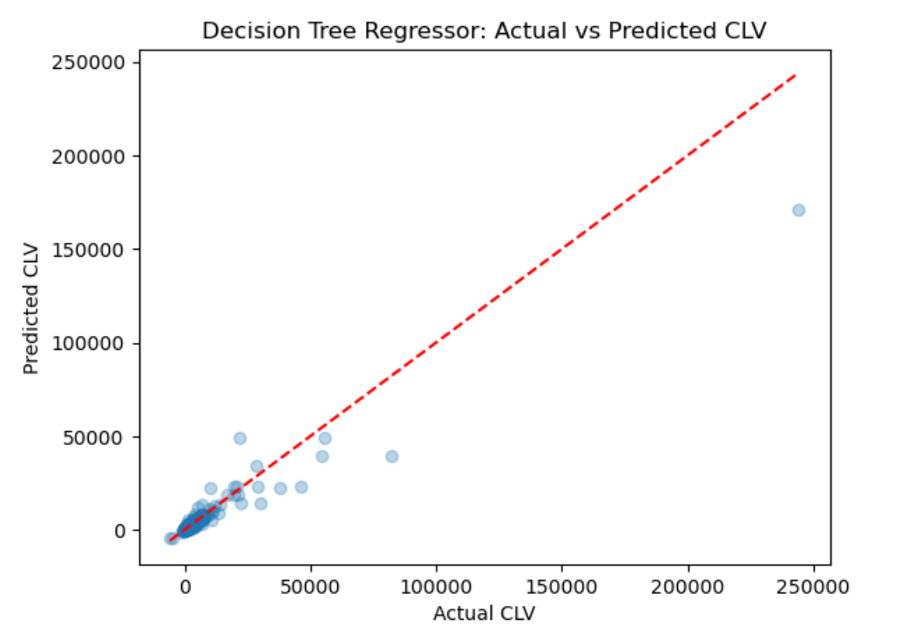
7.a Linear Regression. | 7.b Decision tree regressor
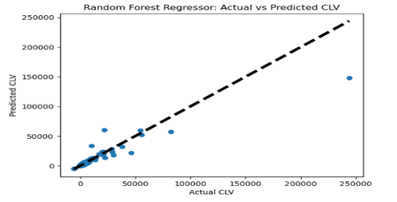 | 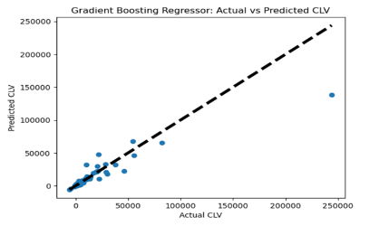
7.c Random Forest Regressor | 7.d Gradient Boosting Regressor
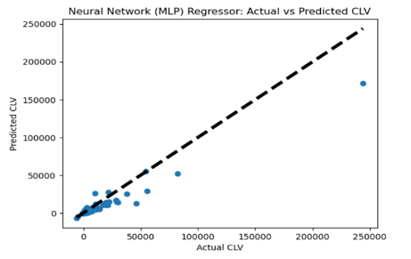
7.e. Neural Network (MLP) Regressor
Fig. 7. Actual vs Predicted CLV of the Models

Table 1. Performance Comparison of Regression Models.
Model | RMSE | R-Squared
Linear Regression | 3538.4382430561664 | 0.8655677584930384
Decision Tree Regressor | 3449.9903682579516 | 0.8695054743253522
Random Forest Regressor | 3841.00056778476 | 0.8415949793639546
Gradient Boosting Regressor | 4014.2722362907466 | 0.8269809818457665
Neural Network (MLP) | 3426.8625781843416 | 0.8739120517892898

The results of this research have significant business operation implications. By employing machine learning models to predict customer lifetime value, companies can better allocate their marketing budget and focus on high-value customers. Churn prediction also enables companies to implement real-time retention strategies, including promotions and loyalty schemes, to reduce customer churn. The results also suggest the need to select the right machine learning model based on specific business needs—whether to focus on accuracy, interpretability, or speed. The RMSE and R-squared for the models are presented in Table 1. The Neural Network (MLP Regressor) was a solid predictive model for CLV, with excellent performance metrics. Its RMSE is the lowest among the models we have examined, and its R-squared is high, showing a good fit. Like any model, however, it is not perfect. The overestimation for higher-value customers is something to investigate, possibly requiring some additional hyperparameter tuning or preprocessing of the data to fix. Decision Tree and Random Forest models were also found to be good predictors; however, they were less accurate in predictions compared to the Neural Network model. Even though Linear Regression is easy to interpret, it was not able to capture complex customer behaviours and had the highest RMSE.
- CONCLUSION AND FUTURE WORK
The proposed ValuVista system highlights the potential of machine learning in predicting CLV and customer churn. The MLP Regressor demonstrated good accuracy in CLV prediction, capturing complex transaction patterns with minimal error, while Decision Tree models excelled in churn classification due to their interpretability and ease of understanding. Future research could explore the integration of real-time analytics into forecasting models. Future studies could investigate incorporating real-time analytics into predictive models, by leveraging streaming data from customer interactions, social media, and support channels, companies may dynamically refine predictions and proactively adapt to emerging customer trends. Additionally, incorporating external socio-economic factors—such as seasonal variations, economic conditions, and global events—could enhance forecasting accuracy. The inclusion of macroeconomic variables and sentiment analysis may enable the development of more adaptive and responsive predictive models.

REFERENCES
- Smith, J., & Doe, A. (2024). Machine Learning Approaches to Customer Lifetime Value Prediction. Journal of Data Science, 18(2), 123-135.
- Sun, Y., Liu, H., & Gao, Y. (2023). Research on customer lifetime value based on machine learning algorithms and customer relationship management analysis model. Heliyon, 9(2023), e13384.
- Kumar, A., Choudhury, T., Singh, K. U., Kotecha, K., & Kumar, G. (2023). Customer lifetime value prediction: Using machine learning to forecast CLV and enhance customer relationship management. Proceedings of the 7th International Symposium on Multidisciplinary Studies and Innovative Technologies (ISMSIT). IEEE.
- Patel, R. (2023). Advancements in Neural Networks for Churn Prediction. International Conference on AI & Marketing, 45(6), 567-579.
- Yean, L. C., & Khoo, V. K. (2010). Customer relationship management: Lifecycle of predicting customer lifetime value. Proceedings of the Second International Conference on Computer Research and Development. IEEE. Deep Learning for Predicting Customer Churn in E-commerce. Proceedings of the AI Summit, 12(5), 67-81.
- Wang, L., & Lee, K. (2022). Feature Engineering Techniques in CLV Modeling. AI & Business Journal, 30(4), 222-238.
- Kumar, A., Choudhury, T., Singh, K. U., Kotecha, K., & Kumar, G. (2023). Customer lifetime value prediction: Using machine learning to forecast CLV and enhance customer relationship management.
- Online Retail 2, Dataset from UCI Irvine Machine Learning Repository. https://archive.ics.uci.edu/dataset/502/online+retail+ii, Accessed on 03/01/2025.
- Gupta, V. (2018). RFM Analysis and ML Models for CLV Estimation. Business Intelligence Journal, 15(2), 89-103.
- Chen, D., & Zhang, X. (2017). Churn Rate Forecasting Using Decision Trees and Neural Networks. AI & Consumer Studies, 10(4), 144-159.
- Kumar, S. (2021). Comparative Study of Regression Models for Customer Behavior Analysis. Data Science Review, 25(3), 189-202.
- Brown, C., & Kim, T. (2020). Random Forest vs. Gradient Boosting for Customer Segmentation. Journal of Business Analytics, 19(1), 100-115.

